Lab 4

Creating a Website Using Load Balancing in AWS

Create a Website using LAMP
In this lab, you will create a LAMP (Linux, Apache, MySQL, PHP) stack instance. You have two options for building a LAMP stack. You can build a LAMP stack yourself or you can launch a prebuilt LAMP stack instance. In this lab, we will use a prebuilt LAMP stack instance.

Built LAMP Stack Instance

- Login to the AWS console, choose EC2, Launch Instance.
- Type in a name for your instance, such as my-app-instance1
- Use default free tier eligible Linux instance, like this:
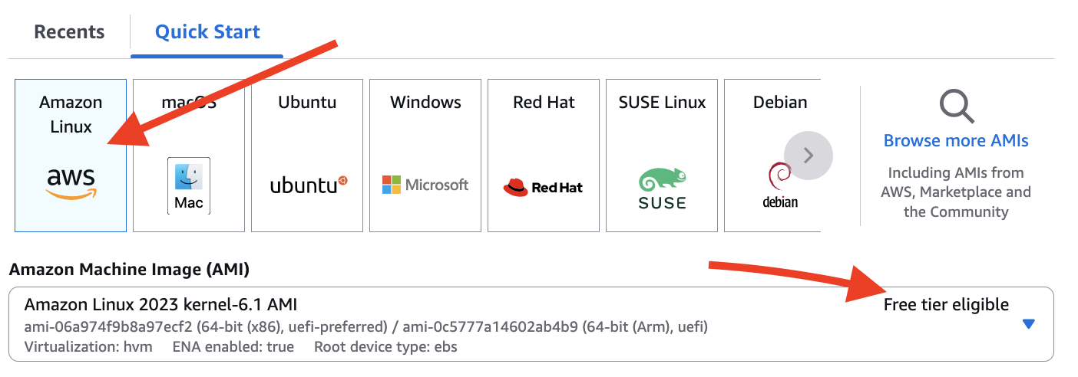
- Use free tier eligible instance type and your own key pair
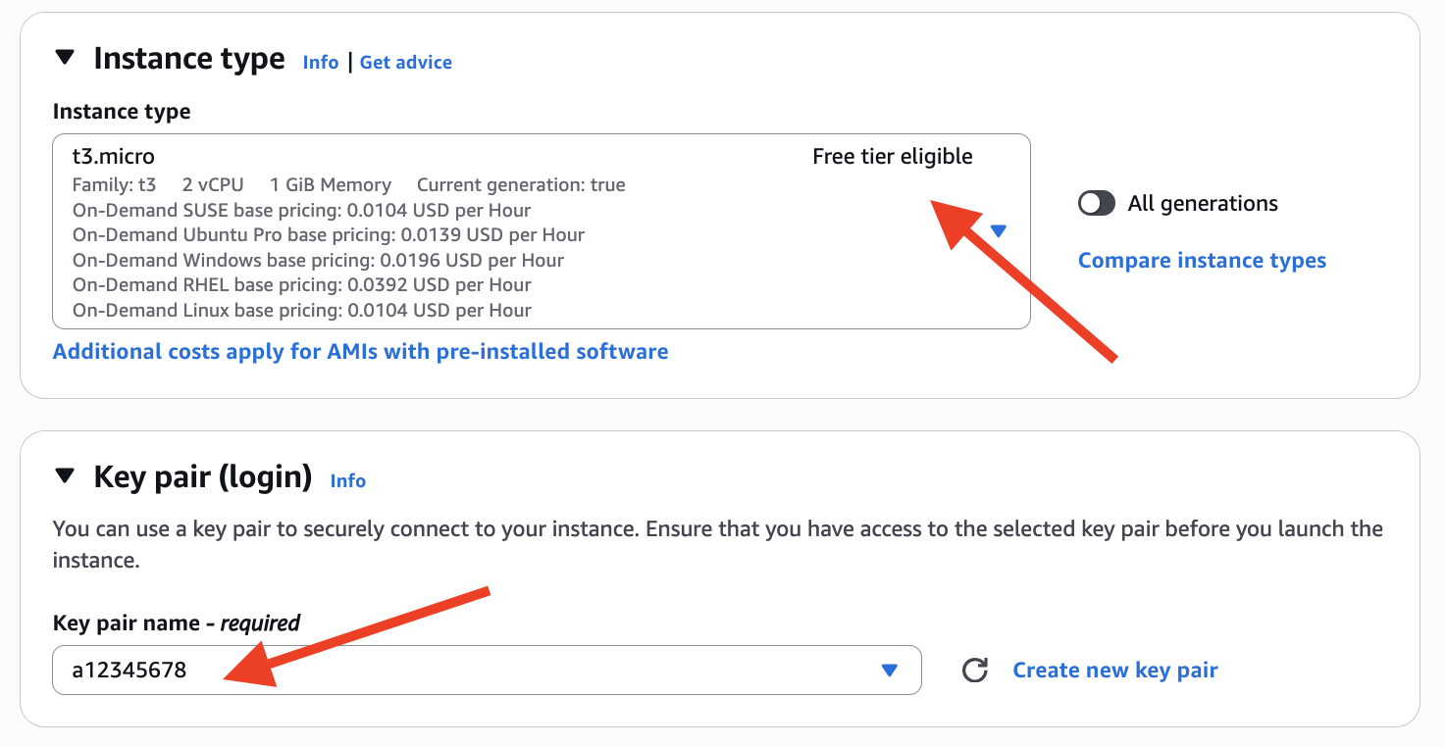
- When selecting the security group, make sure your security group allows both SSH and HTTP access Or create a new security group.
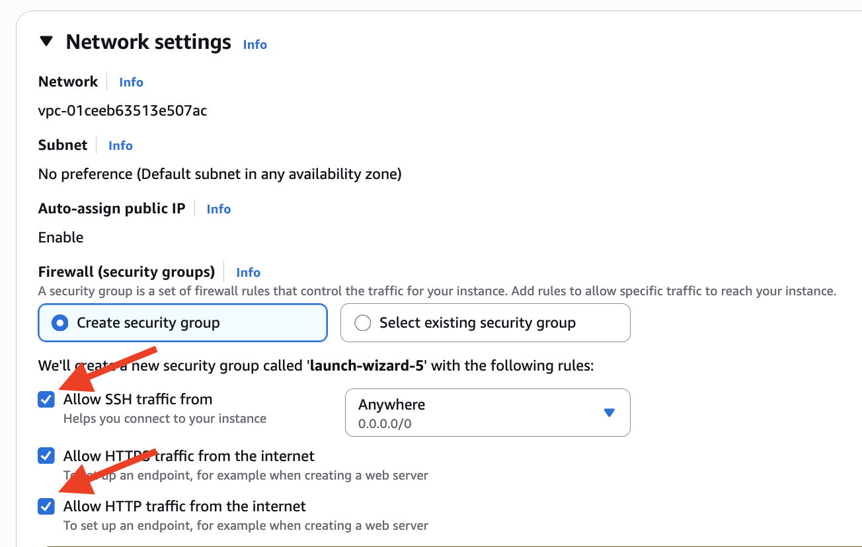
- User Data
AWS user data is the set of commands/data you can provide to an instance at launch time.
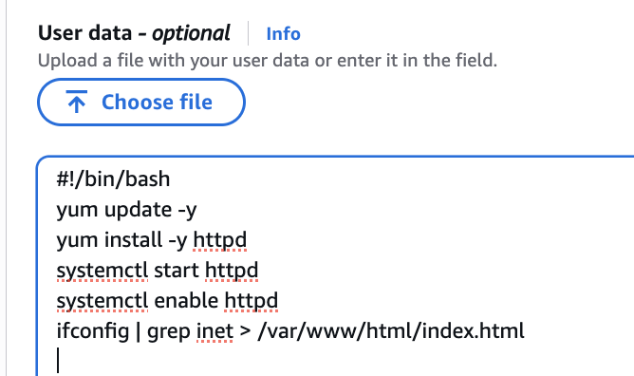
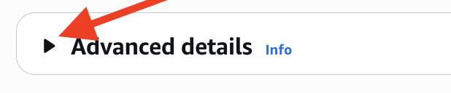

#!/bin/bash
yum update -y
yum install -y httpd
systemctl start httpd
systemctl enable httpd
ifconfig | grep inet > /var/www/html/index.html

- Launch the instance.
- Enter the Public IP address of the instance in your browser.
  - What should be displayed?
  - What got displayed?
How To Test Your Web Site
- Test your web page by entering the Public IP address of the instance. This web page displays metadata about the instance, specifically the Instance ID and the Public IP address.
- For more information on retrieving AWS Instance metadata and user data, see: http://docs.aws.amazon.com/AWSEC2/latest/UserGuide/ec2-instance-metadata.html
- Leave your Ubuntu instance running.

Clone the Original AMI
We are going to take a snapshot of your instance to prepare for the 2nd instance. Make this instance is running.
- Go back to EC2 dashboard.
- Right click on the running instance and select Image & templates -> Create Image.
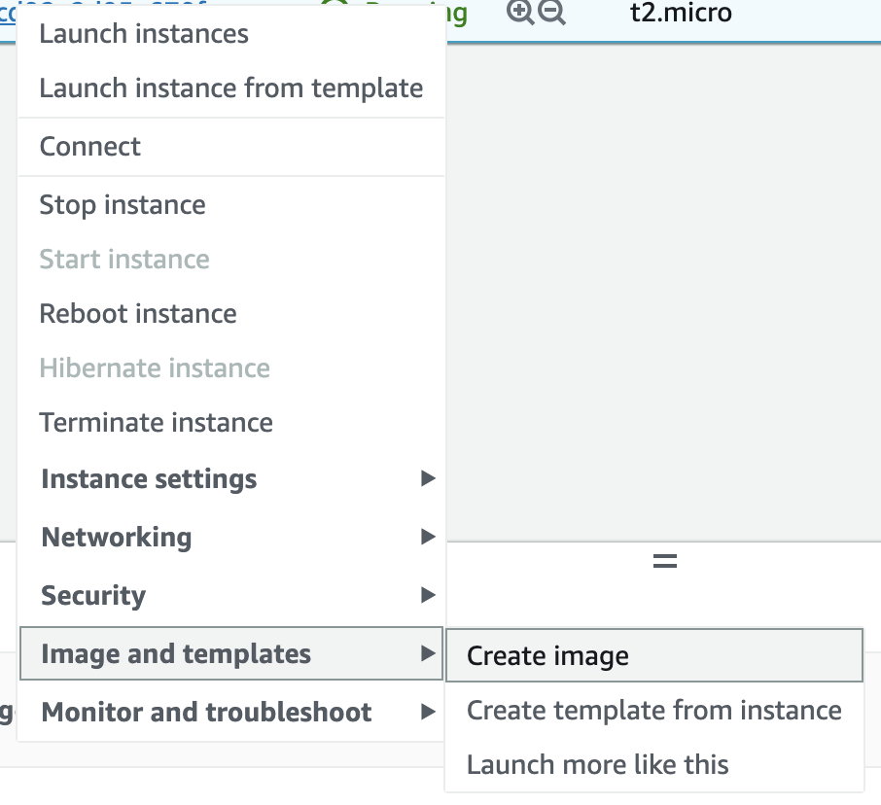
- Write down or record the Instance ID. Add an image name that consists of the Key Name and the word “snapshot.” Example: Linux-ELB-lab-snapshot.
- Click “Create Image”.
- If you click on Snapshots on the left side of your screen, you will not see any snapshots – at this time. Instead, click on AMIs, under the Images area. You will notice that your snapshot is being first built as an AMI image.
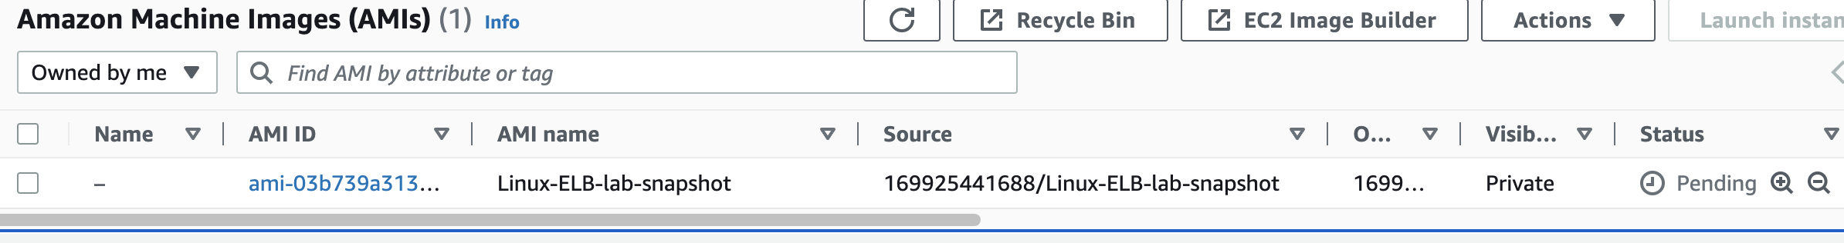
- Refresh this screen until the status changes from “pending” to “available.” Like this:
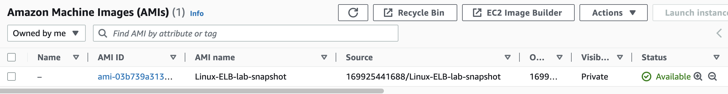
- Now, go back to the Snapshots tab. You have now cloned your original image.
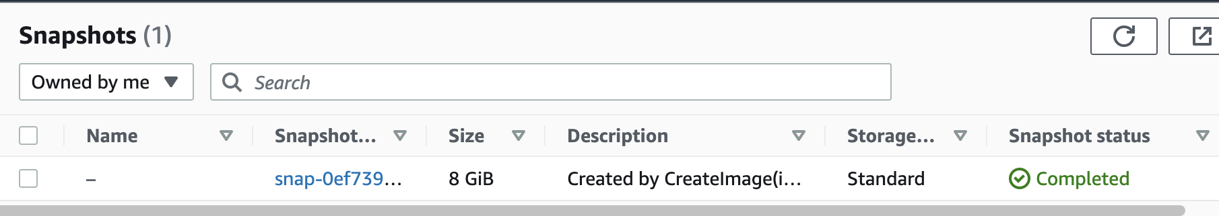
- Go back to the AMI image screen. Select the snapshot of the new AMI, right click and choose Launch instance from AMI.
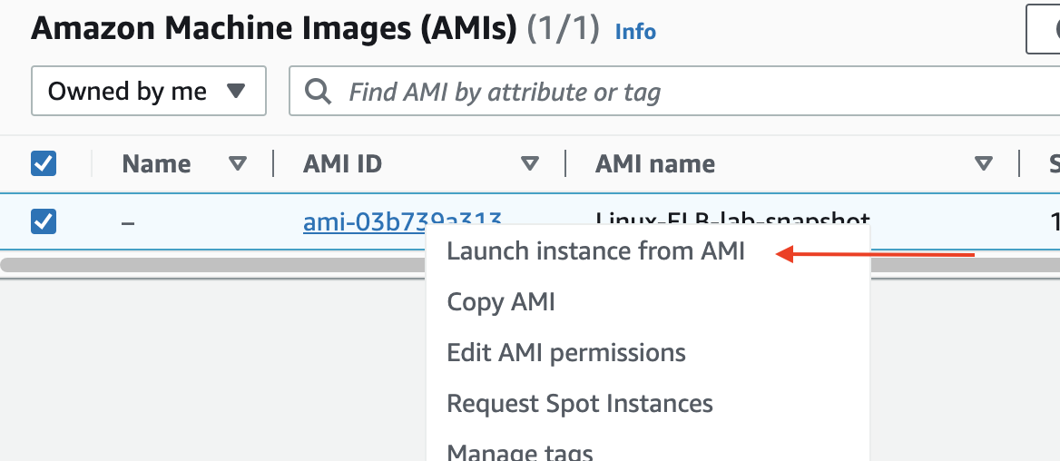

- Type in a name for your instance, such as my-app-instance2
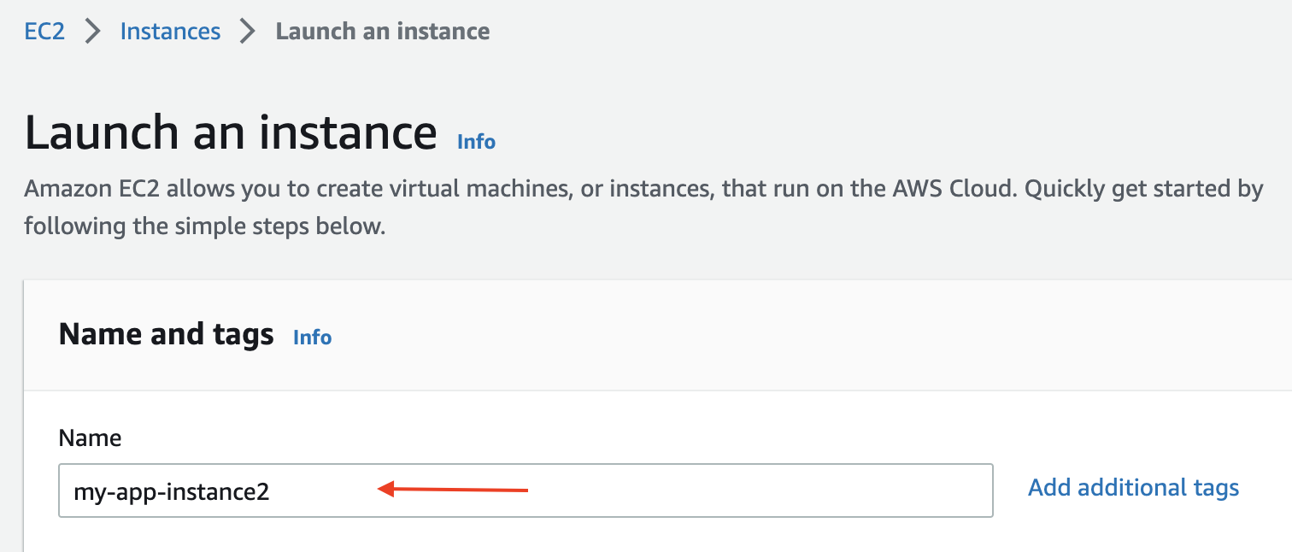
- In the “Application and OS” section, you should see your own snapshot is chosen.
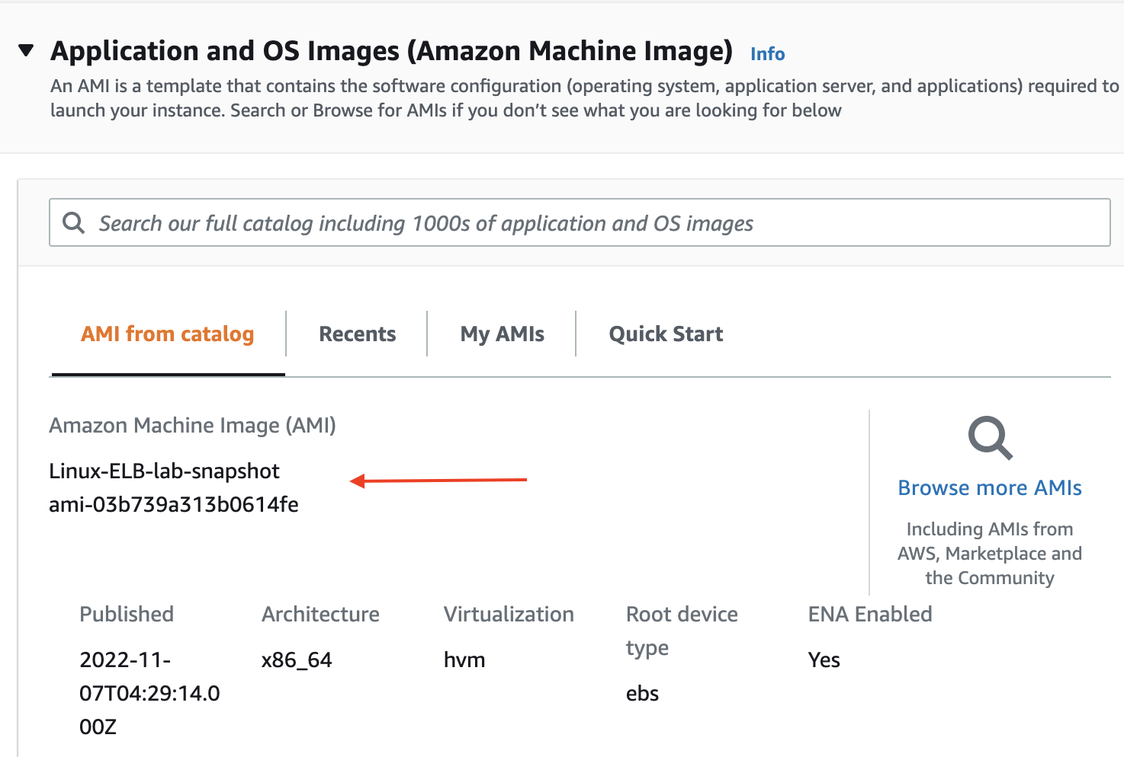
- Select the same Key Pair as the first instance.
- Use the same Security Group as you used for the first instance, or create another one wit same settings
- Go back to your EC2 Dashboard, make a screenshot, and then paste it below
Make sure to show both of your instances are running.

- Enter the IP address of your new instance. It should display the Instance ID and Public IP address of the instance.
- Do not create the load balancer unless website program works on the second instance! (Did you remember to open port 80 HTTP on the security group for the new instance?)
- Write in the Instance ID and Public IP address for each instance:
 | Instance #1 | Instance #2 (Cloned instance)
Instance ID
Public IP address
Private IP address

- You should see your two instances showing the same page.
- You need to SSH into your second instance to rerun:
ifconfig | grep inet > /var/www/html/index.html
- Double check and make sure that your two instances are showing different pages, before moving on.
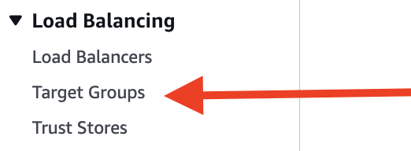
Create a Target Group
- On the left navigation bar,
find and select “Target Groups”.
- Click “Create target group” button.
- In “Basic configuration” section, select “IP addresses”
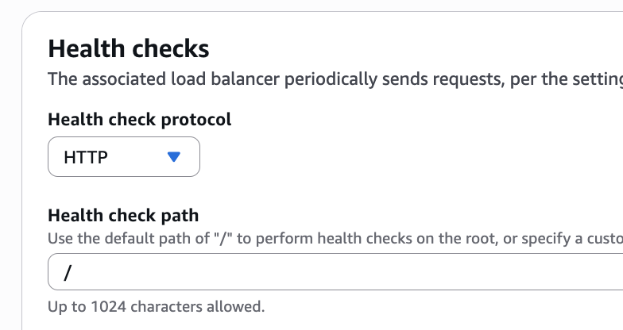
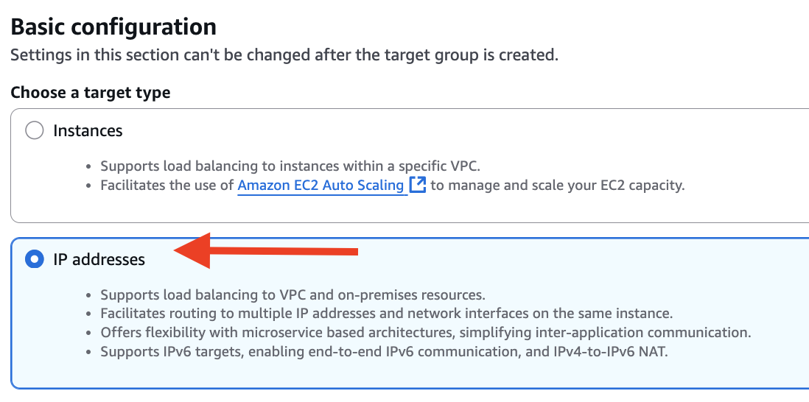
- Give your target group a name. Eg, ELB-lab-tg
- Health check path go with “/” (should be default)

- Click “Next” button.
- Under “Step 2: Specify IPs and define ports”, add your private IPs of instances
- Click “Include as pending below” button
- You should see your two IPs got shown under “Step 3 Review IP targets to include in your group” as follow:
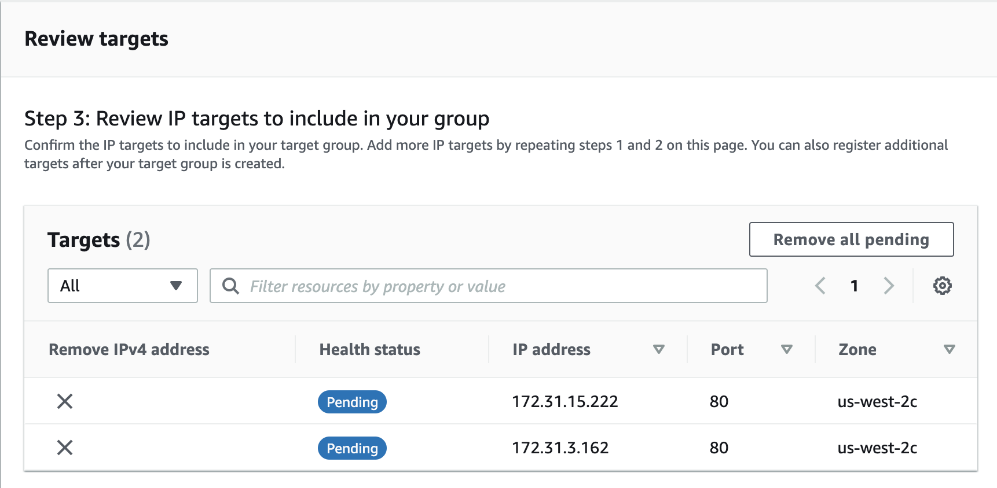
- Click “Create target group”
- In the Target groups dashboard, select the one you just created
- Open “Targets” tab, you should see your two IP got shown
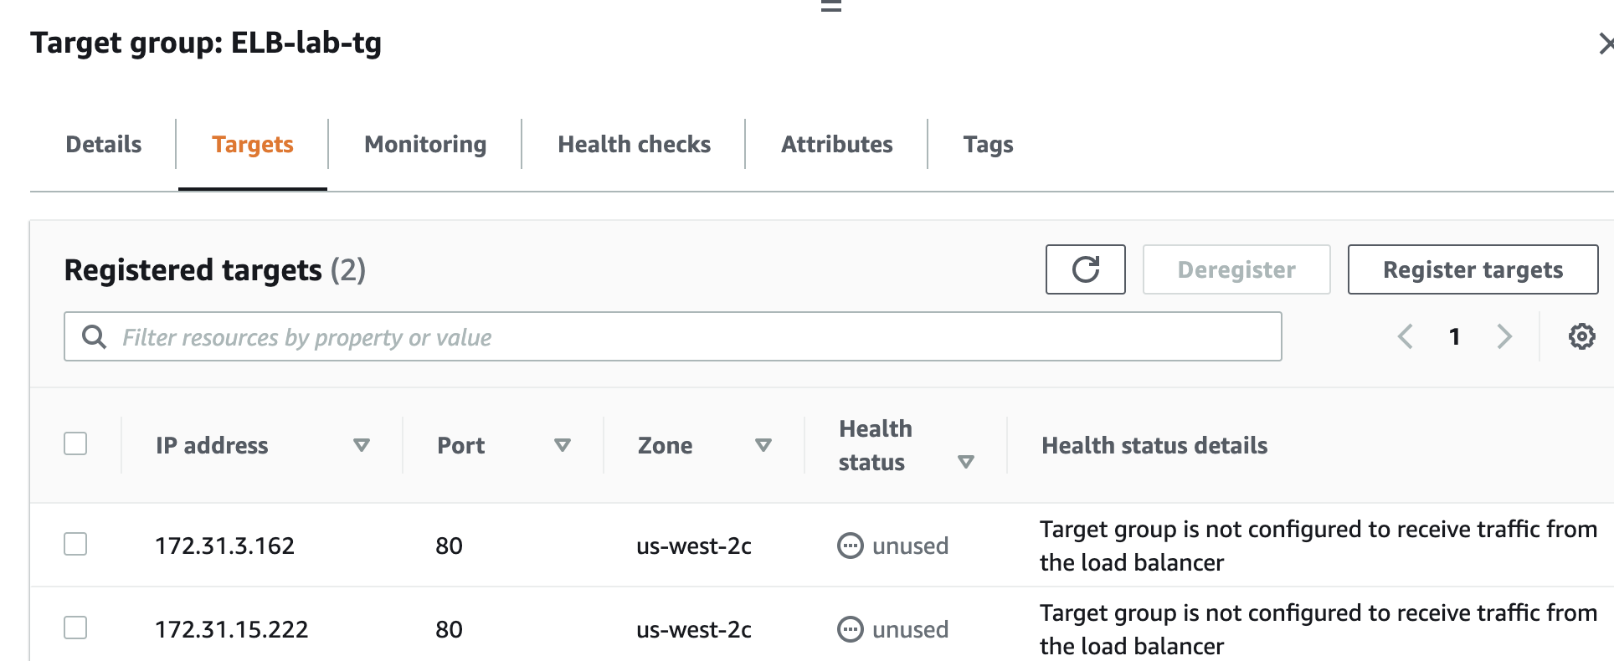
- Note down which AZs your instances are in.

Create a Load Balancer
You are now going create a load balancer to manage the traffic to your website.
- On the left navigation bar, find and select “Load Balancers”.
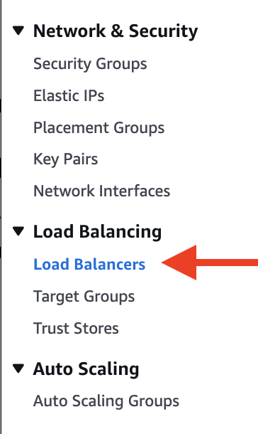
- Click “Create load balancer” button.
- Select “Application Load Balancer” and then click Create button.
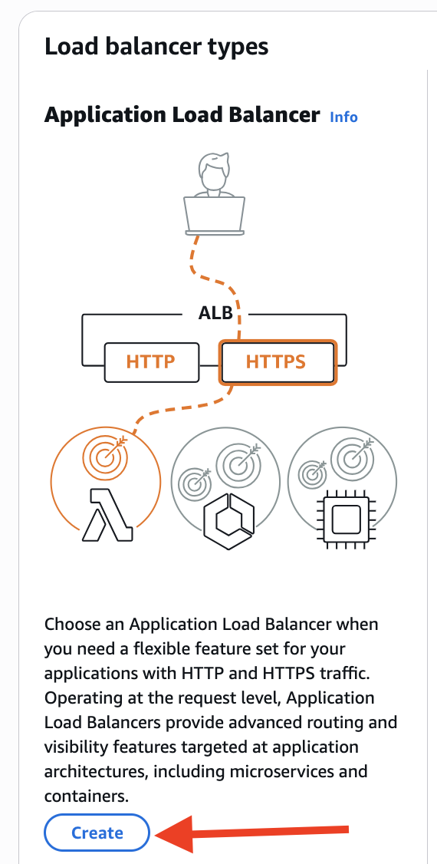
- Enter a name like “A00123456-load-balancer” .
- Select your security group. Make sure you have selected only one group.
- In “Network mapping” section, make sure to select AZs your instances are in. Or select all AZs.
- In “Listeners and routing” section, choose the target group you just created.
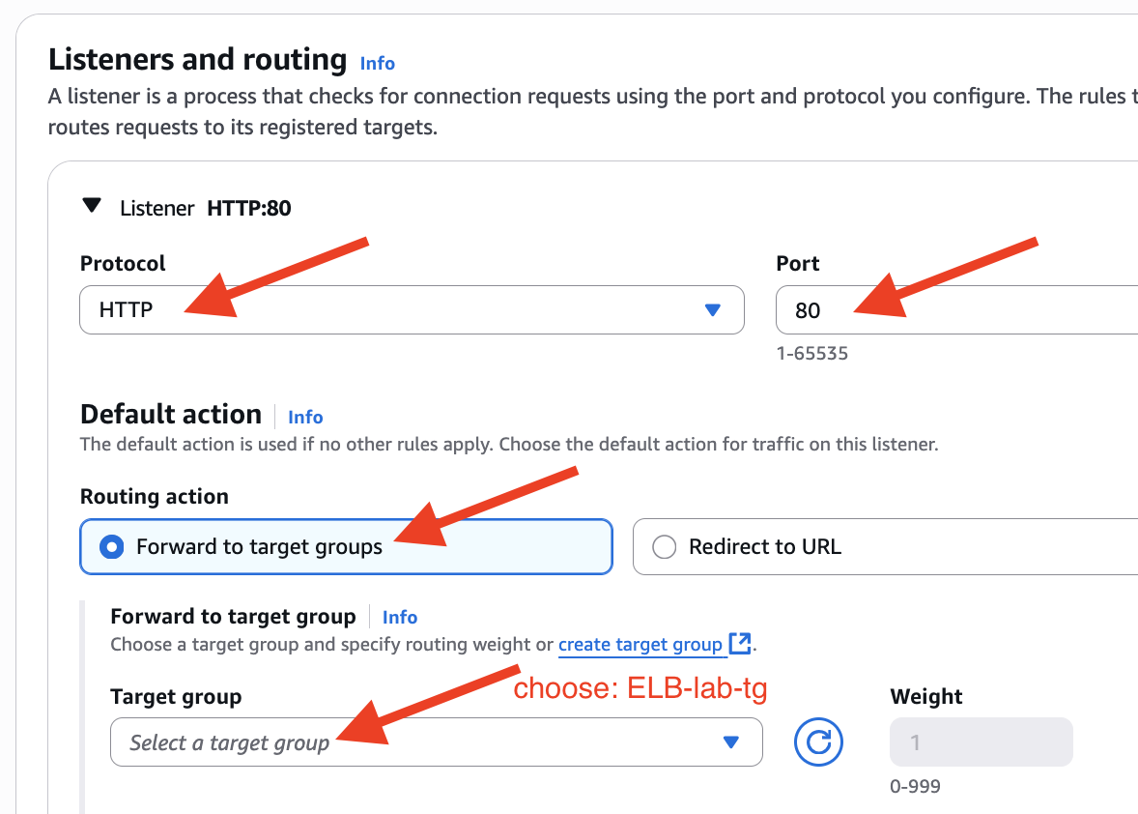
- Click “Create load balancer” button at the bottom of the web page.
- The status of your LB is shown as “provisioning”
- Wait till the LB status is “active”
- Select your LB, in the Description tab, find DNS name and copy it.
- Paste it into a browser.
- You should see one of your two instance’s (private) IP
- Keep refreshing the web page, you should see the other one got shown

Note: if you are seeing “503 Service Temporarily Unavailable”, you may not include your instances into your target group successfully.

- Stop here to show your LB behavior to your instructor to get sign-off.
- Go to the EC2 Dashboard. Stop one of your instances.
Refresh the tab on your browser containing the URL of the load balancer.
- Go to the EC2 Dashboard. Restart the instance that was stopped.
Refresh the tab on your browser containing the URL of the load balancer.

Teardown
After each step, make a screenshot to show successfully deletion/removal.
- Delete the load balancer.
- Delete the target group.
- Deregister the AMI.
- Delete your snapshot.
- Terminate all your running instances.

